**Assignment -1 Problem Statement :**

lo T-Based Industry - Real-Time River Water Quality Monitoring and Control System

**Domain:** Internet of Things

|  |  |
| --- | --- |
| Assignment Date | 08 NOVEMBER 2022 |
| Student Name | R.RAGAVI |
| Student Roll Number | 820519106031 |
| TEAM ID | PNT2022TMID52417 |
| Maximum Marks | 2 Marks |

**Assignment 1: Circuit design Home automation system in Tinker Cad.**

**Circuit diagram :**

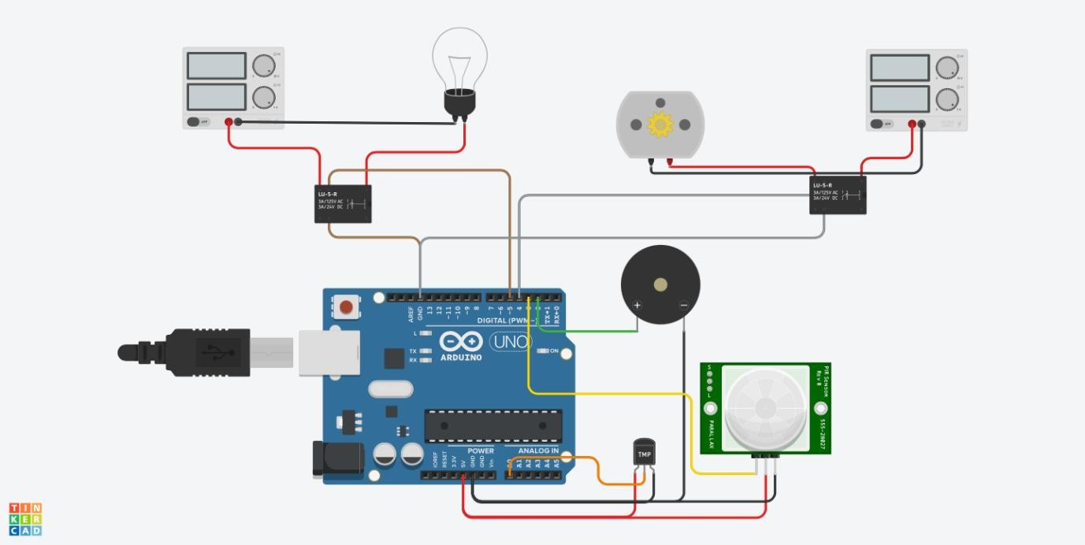

Program:

Arduino Uno Code :

#define buzzer 2

#define pir 3

#define motor 4

#define light 5

#define temp A0

void setup()

{

pinMode(pir, INPUT); pinMode(temp, INPUT); pinMode(buzzer, OUTPUT); pinMode(light, OUTPUT); pinMode(motor, OUTPUT); Serial.begin(9600);

}

void loop()

{

if(digitalRead(pir)==HIGH)

{

digitalWrite(light,HIGH); digitalWrite(motor,HIGH);

}

else

{

digitalWrite(light,LOW); digitalWrite(motor,LOW);

}

if(analogRead(temp)>200)

{

Serial.print("high temperature alert"); digitalWrite(buzzer,HIGH);

delay(500); digitalWrite(buzzer,LOW); delay(400);

}

}